Summary

This document records the results of Location Quotient with two approaches. The first approach uses employment (total employment for HBW), and sizeterms (HBS, HBR and HBO) to calculate LQ. Because the HBR sizeterms value (HBR sizeterms = TotEmp + 1.278*HHold + 4.6833*ParkAcres) is much larger than other three purposes’ sizeterms value, the centers identified by LQ for HBR is not reliable. The second approach uses TDM trips to calculate LQ. Because some TAZs only have HBO and HBR trips, the centers identified by LQ for HBO and HBR is not reliable.

Table 1 shows the number of TAZs identified for centers by different approaches.

Table 1 Number of TAZs identified for centers

|  |  |  |  |  |
| --- | --- | --- | --- | --- |
|  | hbwci | hbsci | hbrci | hboci |
| EMP and SizeTerm 75% percentile | 157 | 549 | 600 | 598 |
| EMP and SizeTerm LQ | 570 | 493 | 1383 | 842 |
| TDM Trips LQ | 606 | 430 | 1469 | 1412 |

1. Employment and sizeterms approach

HBW Location Quotient

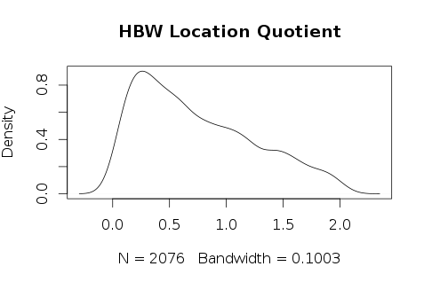

Table 1.1 HBW Location Quotient Statistical Descriptive

|  |  |  |  |  |  |
| --- | --- | --- | --- | --- | --- |
| Min | 1st Qu | Median | Mean | 3rd Qu | Max |
| 0.00758 | 0.30720 | 0.63040 | 0.74300 | 1.10400 | 2.04800 |

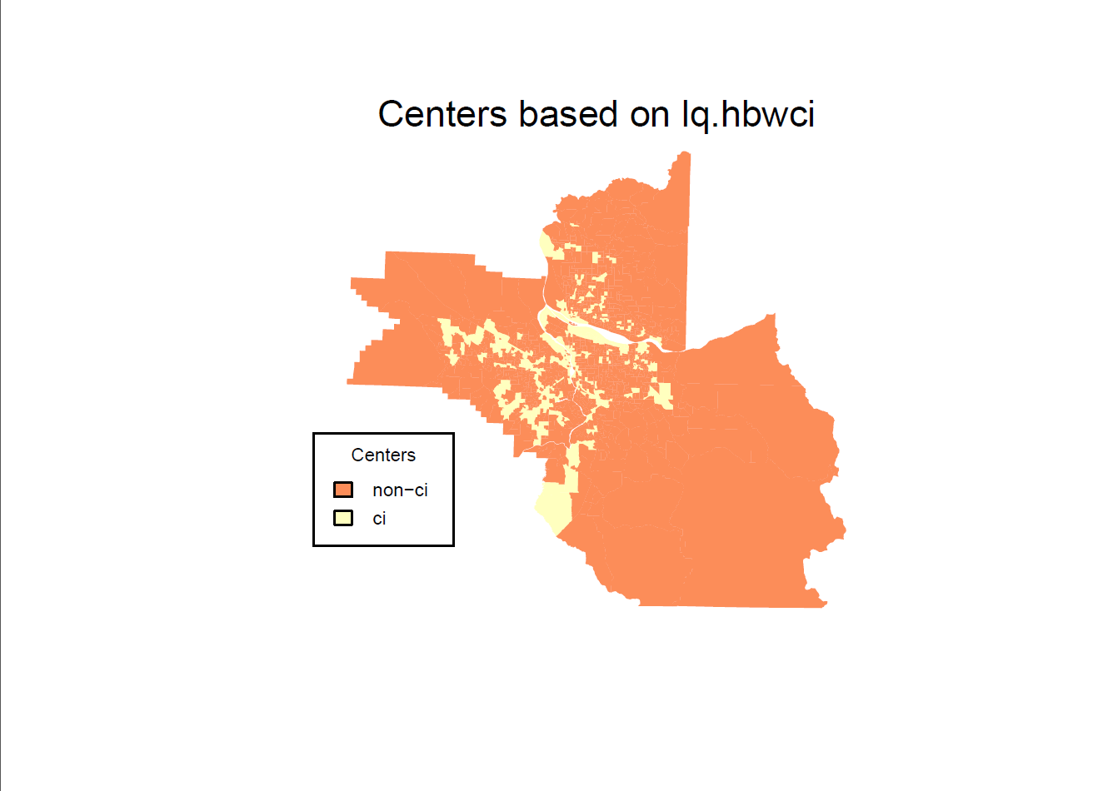

HBS Location Quotient

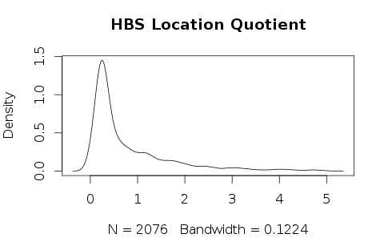

Table 1.2 HBS Location Quotient Statistical Descriptive

|  |  |  |  |  |  |
| --- | --- | --- | --- | --- | --- |
| Min | 1st Qu | Median | Mean | 3rd Qu | Max |
| 0.00093 | 0.24090 | 0.37760 | 0.79280 | 1.08100 | 4.98500 |

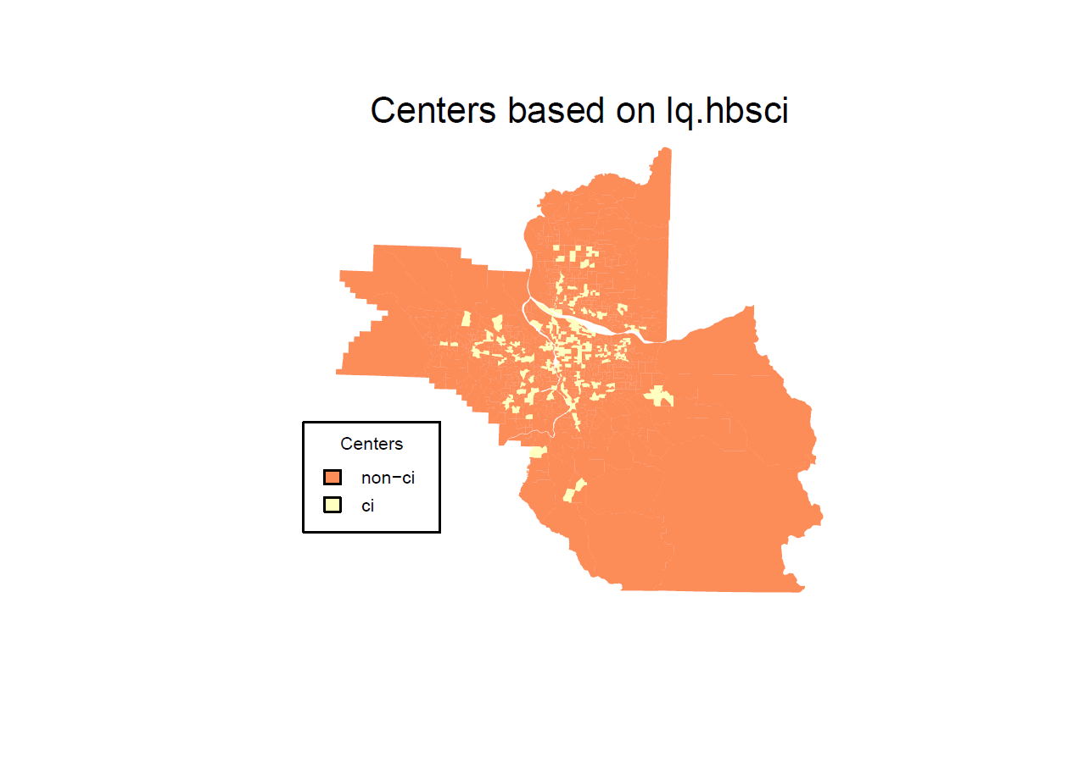

HBR Location Quotient

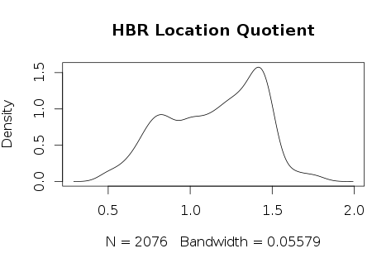

Table 1.3 HBR Location Quotient Statistical Descriptive

|  |  |  |  |  |  |
| --- | --- | --- | --- | --- | --- |
| Min | 1st Qu | Median | Mean | 3rd Qu | Max |
| 0.4575 | 0.9060 | 1.1850 | 1.1450 | 1.3860 | 1.8260 |

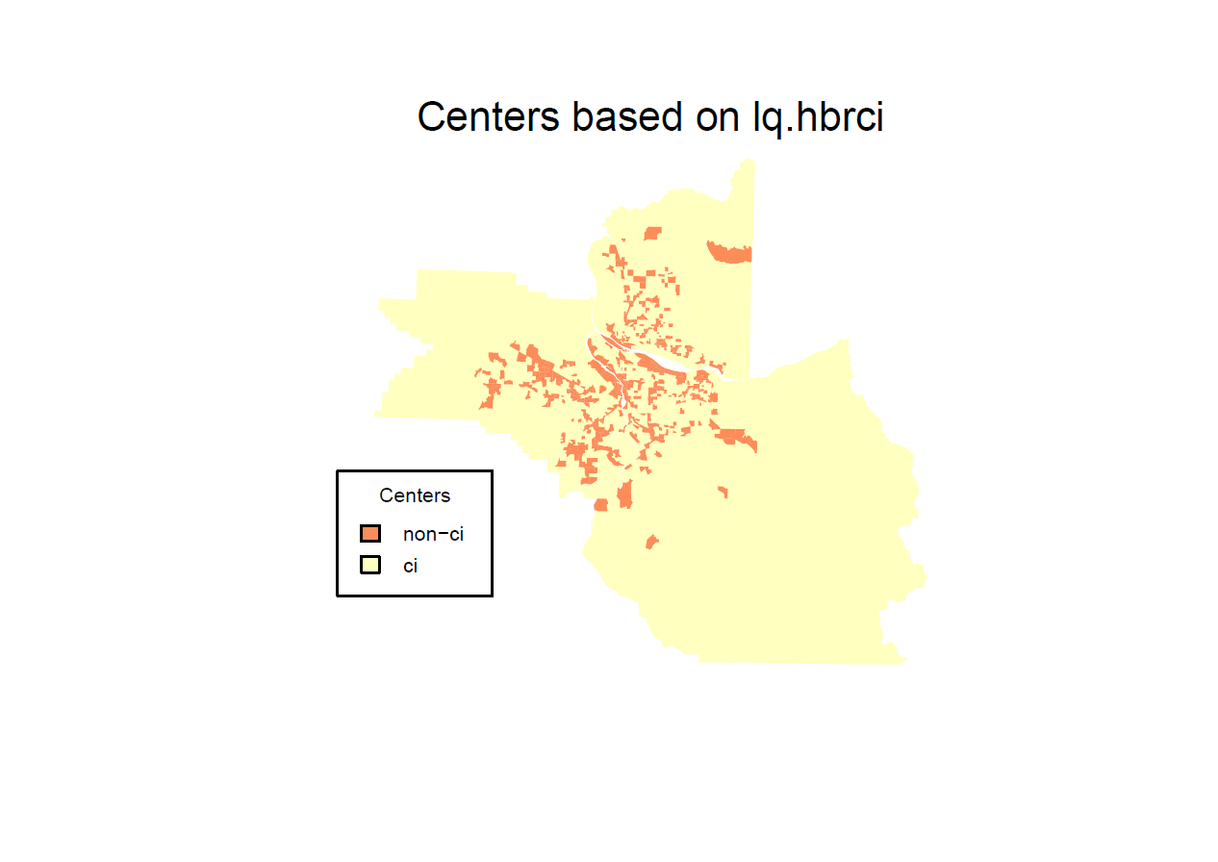

HBO Location Quotient

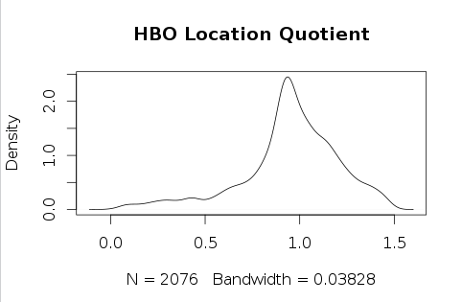

Table 1.4 HBO Location Quotient Statistical Descriptive

|  |  |  |  |  |  |
| --- | --- | --- | --- | --- | --- |
| Min | 1st Qu | Median | Mean | 3rd Qu | Max |
| 0.00275 | 0.85340 | 0.96030 | 321.500 | 1.11600 | 1.48600 |

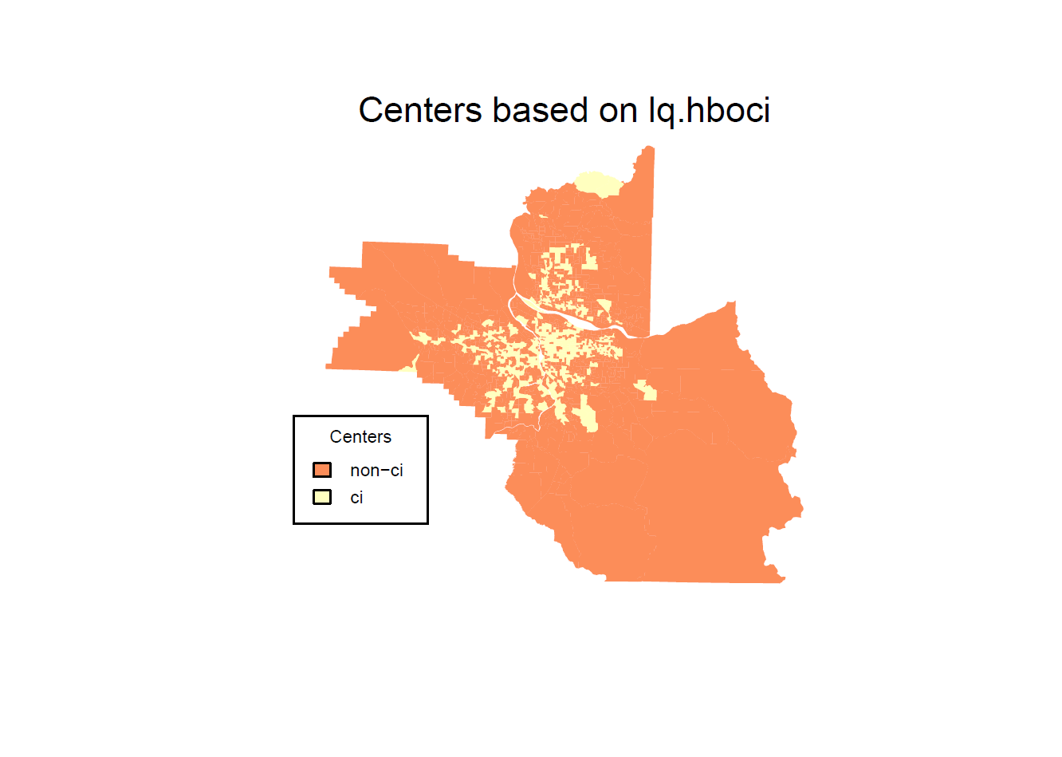

2. TDM trips approach

HBW Location Quotient

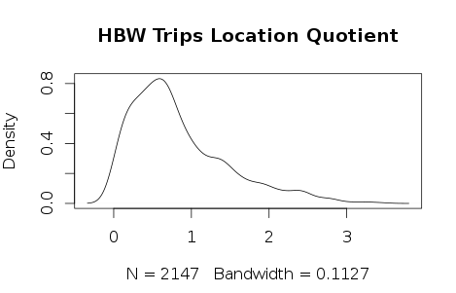

Table 2.1 HBW Location Quotient Statistical Descriptive

|  |  |  |  |  |  |
| --- | --- | --- | --- | --- | --- |
| Min | 1st Qu | Median | Mean | 3rd Qu | Max |
| 0.000 | 0.3793 | 0.6780 | 0.8382 | 1.1580 | 3.4610 |

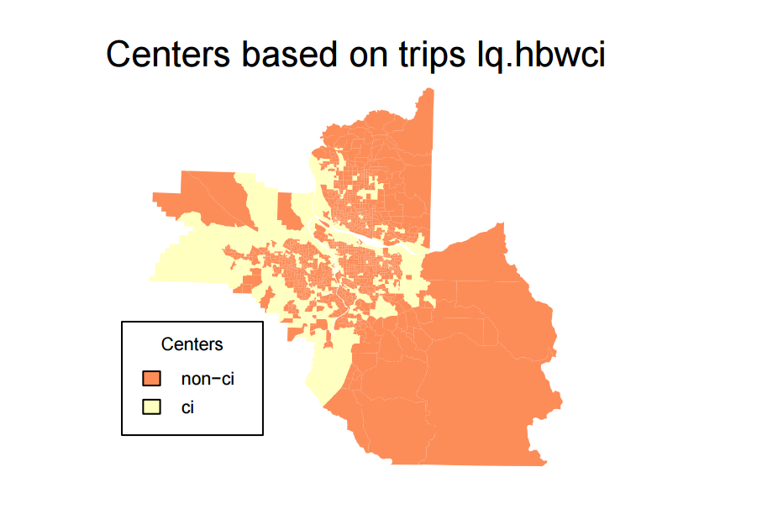

HBS Location Quotient

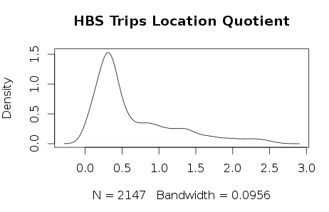

Table 2.2 HBS Location Quotient Statistical Descriptive

|  |  |  |  |  |  |
| --- | --- | --- | --- | --- | --- |
| Min | 1st Qu | Median | Mean | 3rd Qu | Max |
| 0.000 | 0.2697 | 0.3985 | 0.6534 | 0.9299 | 2.6180 |

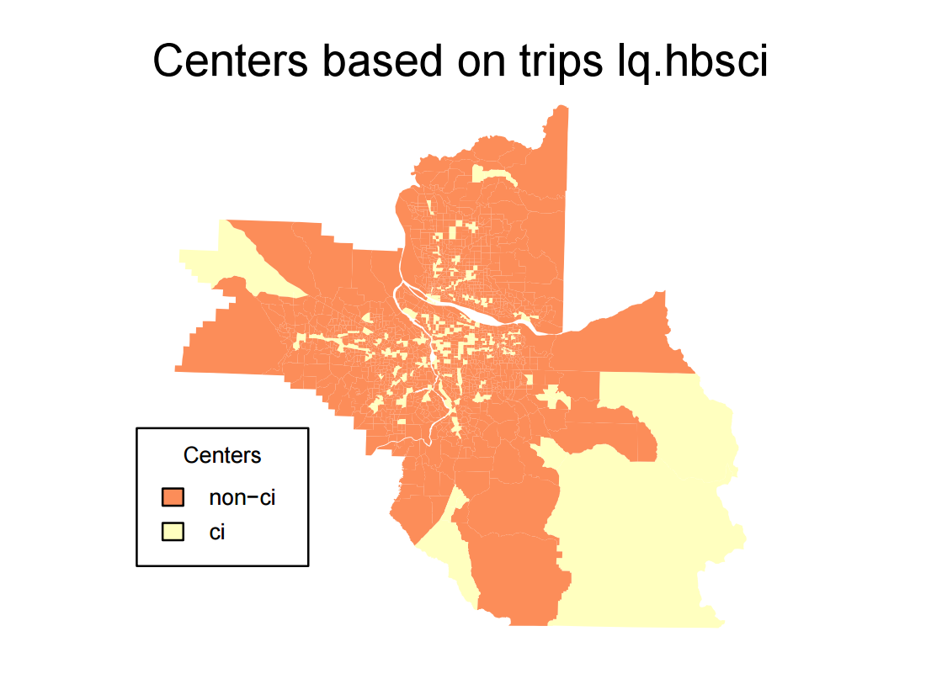

HBR Location Quotient

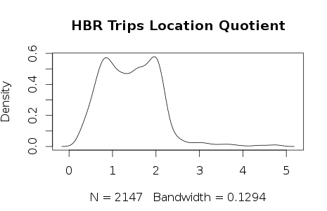

Table 2.3 HBR Location Quotient Statistical Descriptive

|  |  |  |  |  |  |
| --- | --- | --- | --- | --- | --- |
| Min | 1st Qu | Median | Mean | 3rd Qu | Max |
| 0.2219 | 0.8547 | 1.4000 | 1.4270 | 108990 | 4.7950 |

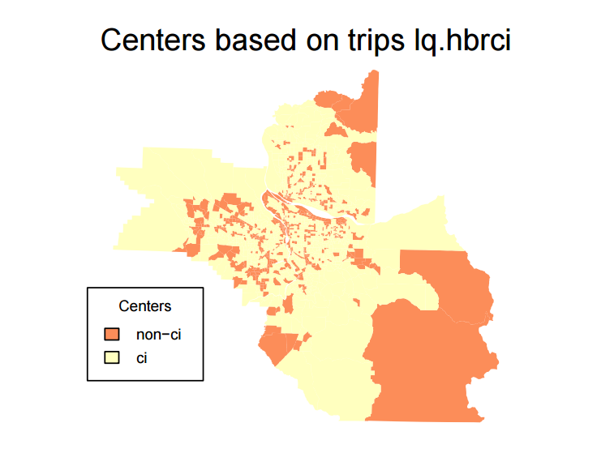

HBO Location Quotient

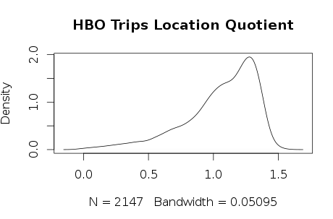

Table 2.4 HBO Location Quotient Statistical Descriptive

|  |  |  |  |  |  |
| --- | --- | --- | --- | --- | --- |
| Min | 1st Qu | Median | Mean | 3rd Qu | Max |
| 0.00275 | 0.85340 | 0.96030 | 321.500 | 1.11600 | 1.48600 |

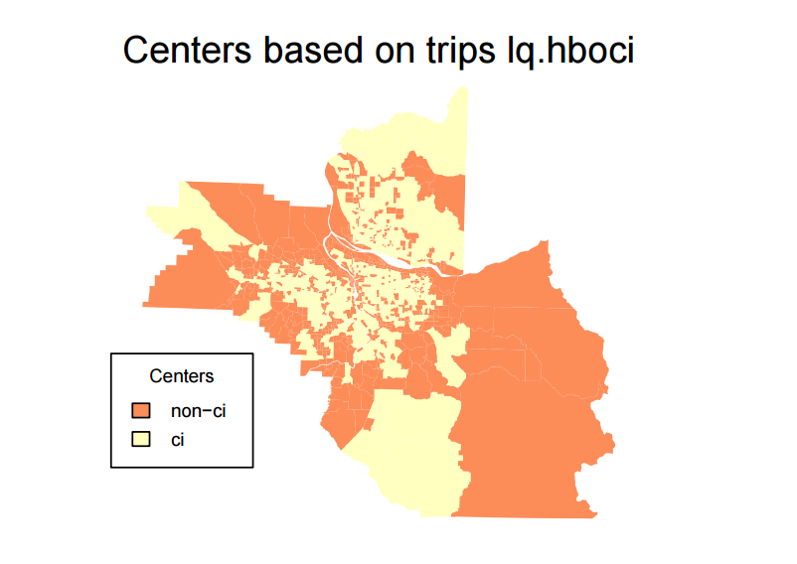

3. OHAS trip ends

HBW trips destination TAZ frequency

There are 793 HBW destination TAZs.

Table 3.1 Summary of HBW destination TAZs frequency

|  |  |  |  |  |  |
| --- | --- | --- | --- | --- | --- |
| Min | 1st Qu | Median | Mean | 3rd Qu | Max |
| 1 | 1 | 1 | 1.879 | 2 | 8 |

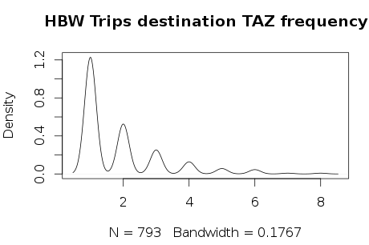

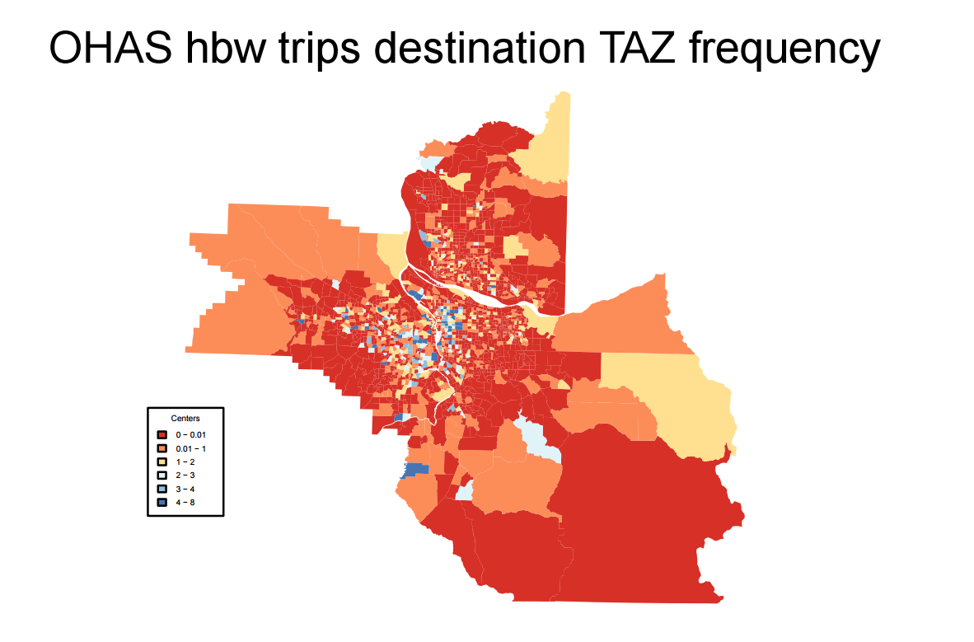

HBS trips destination TAZ frequency

There are 762 HBS destination TAZs.

Table 3.2 Summary of HBS destination TAZs frequency

|  |  |  |  |  |  |
| --- | --- | --- | --- | --- | --- |
| Min | 1st Qu | Median | Mean | 3rd Qu | Max |
| 1 | 1 | 2 | 2.56 | 3 | 23 |

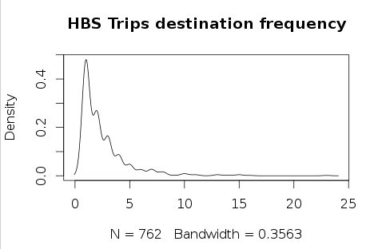

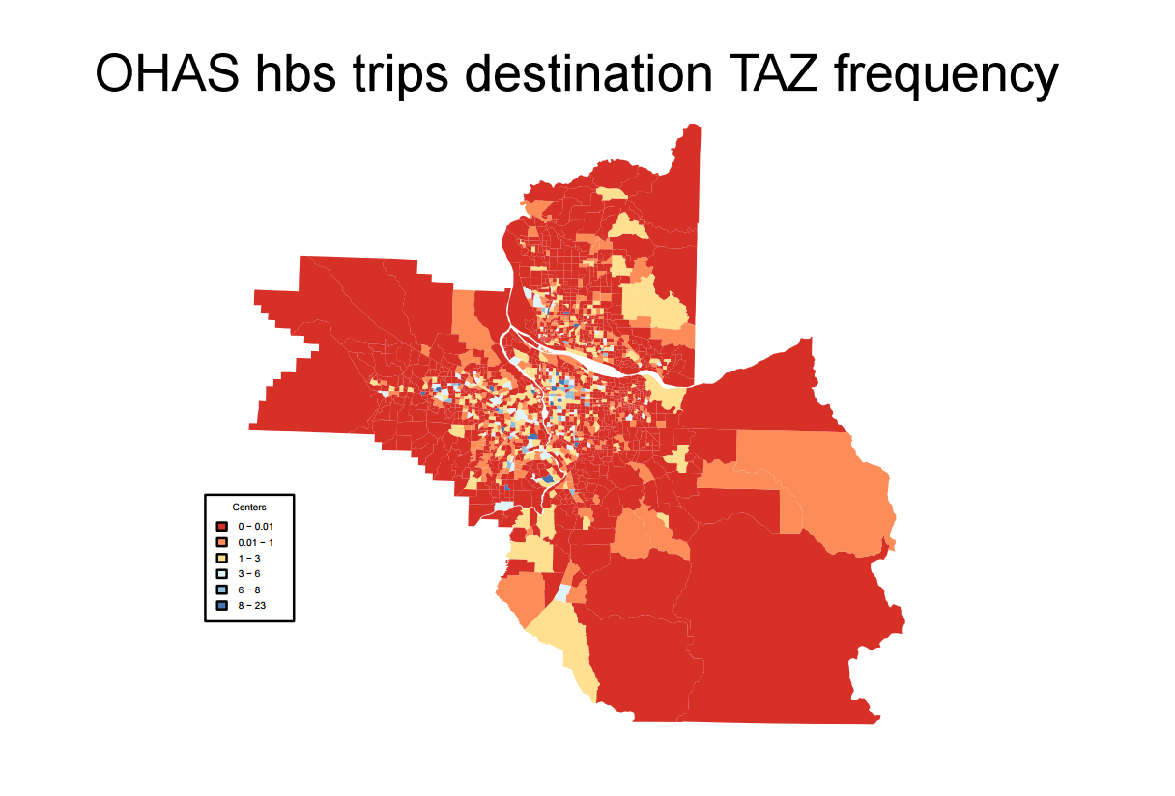

HBR trips destination TAZ frequency

There are 694 HBR destination TAZs.

Table 3.3 Summary of HBS destination TAZs frequency

|  |  |  |  |  |  |
| --- | --- | --- | --- | --- | --- |
| Min | 1st Qu | Median | Mean | 3rd Qu | Max |
| 1 | 1 | 2 | 2.421 | 3 | 20 |

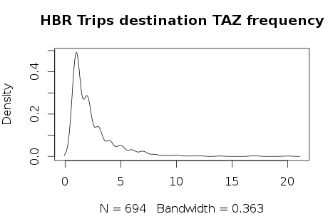

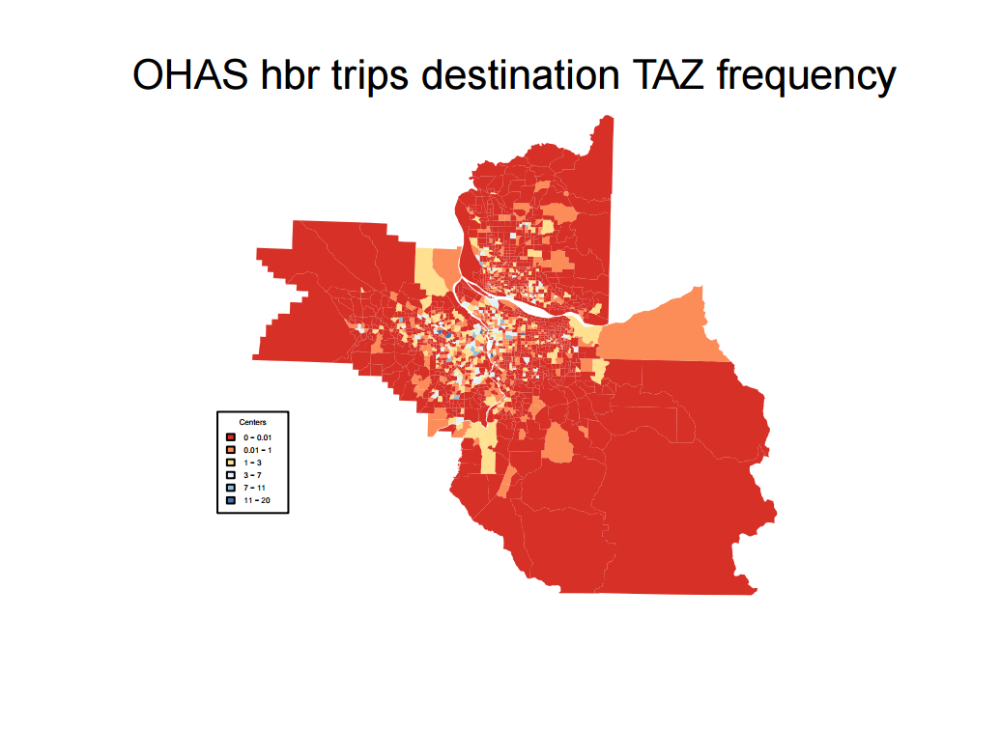

HBO trips destination TAZ frequency

There are 1455 HBR destination TAZs.

Table 3.4 Summary of HBS destination TAZs frequency

|  |  |  |  |  |  |
| --- | --- | --- | --- | --- | --- |
| Min | 1st Qu | Median | Mean | 3rd Qu | Max |
| 1 | 2 | 3 | 5.271 | 7 | 41 |

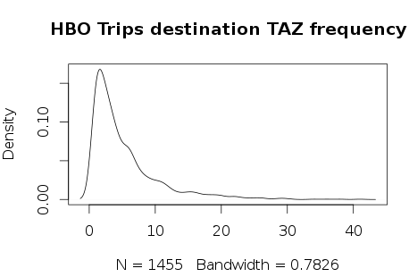

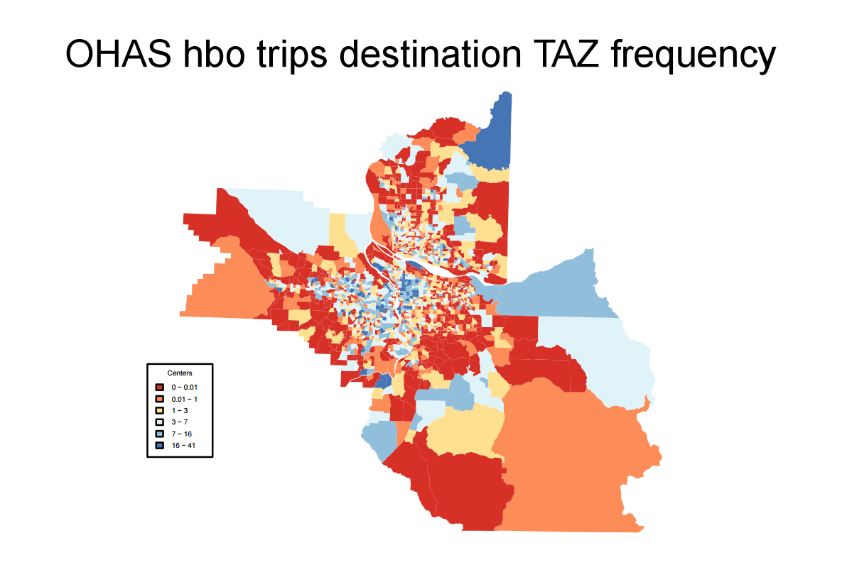

4. Weights for LQ and additional spatial statistics

For weighting and utilizing additional spatial statistics, I summarize the methodology used by the Carroll et al. (2008).

First, Carroll et al. suggest that the first- and second-order distinction is necessary to ensure industrial concentrations in smaller countries are not over emphasized. The elimination of smaller relative sized counties may actually be detrimental to this effort. In fact, smaller counties may have denser social networks and therefore be more likely candidates for cluster centers. (This can be utilized to solve the problem of HBO centers.)

Second, Carrol et al. use Gi* and location quotients to create a two-way classification of counties (Table 1).

Table 4.1 Classification of counties

|  |  |  |
| --- | --- | --- |
| Gi* | Location quotient | |
| >1.0 | ≤1.0 |
| High (>1.96) | Auto potential cluster region (51 counties) | Auto periphery (25 counties) |
| Low (≤1.96) | Auto specialized county (63 counties) | Auto-free (226 counties) |

Those counties with *Gi*∗ indices greater than 1.96 and high location quotients (greater than 1.00) are identified as potential cluster regions.

The *Gi*∗ statistics are expressed in standard deviations from the means as follows (Feser et al. 2005):

, for all *j*

where, *x* is county employment in NAICS 336; *wi j* is the spatial weight that defines neighboring counties *j* to county *i* ; *Wi* is the sum of weights *wi j* ; . *x* represents the mean of county-level sector employment for the region; [i.e., ; ; . The index for *Gi* ∗ indicates how similar a county is to its neighbors. A high *Gi*∗ value indicates that high valued counties tend to be situated near each other and a low *Gi*∗ index indicates that low valued counties are near each other.

For spatial weight matrix, Carroll et al. use an inverse distance spatial weights matrix with a 450 mile threshold. (We need to decide the threshold for our project. Carroll’s study uses county as analysis unit, and their study area is four state in the Midwestern USA. Their rationale for this threshold stems from the work of Klier (2005) who argued that in the auto industry 450 miles to an assembly plant is an important distance since it is the distance that deliveries can be made reliably within a day, which is an important element of the just-in-time production system.)

Carroll also lists other spatial statistics that may be used to delineate potential cluster regions, including Moran’s *I*, Getis and Ord’s *Gi*∗, as well as the local *G* statistic.

Following paragraphs which discuss how to decide spatial weight matrix are copied form Carroll et al.’s paper.

An important component of local measures of spatial autocorrelation is the specification of the local neighborhood as defined by the spatial weights matrix (Unwin and Unwin 1998). The spatial weights matrix can be defined using rook or queen’s measures of adjacency, distance between county centroids, inverse distance function, inverse distance squared, stochastic weights, and the like (Getis and Aldstadt 2004;Wong and Lee 2005; Mitchell 2005; Unwin and Unwin 1998; Fang 2006).

Selection of a spatial weights matrix ideally should be derived from the cluster development literature, but there is little consensus in the cluster literature as to the appropriate spatial extent of a cluster. Porter (2000) suggested that a cluster can range from a single city to neighboring countries. On the other hand, May et al. (2001) posited that a cluster is characterized by firms agglomerating in a region up to 50 miles in radius. Litzenberger and Sternberg (2005) noted that an exact threshold for clusters does not exist. Martin and Sunley (2003, p 12) strongly criticized this lack of geographic specificity, stating that “the key weakness is that there is nothing inherent in the concept [i.e. clusters] itself to indicate its spatial range or limits, or whether and in what ways different clustering processes operate at different geographical scales.” One method of defining the spatial weights matrix was proposed in an ESRI White Paper (2005) which advised that one try alternative distance functions and then select the one that shows the greatest amount of clustering. Most previous studies using *Gi\** have used adjacency or first-order nearest neighbors, including the county itself (Feser et al. 2005; Helsel et al. 2007). Use of a first-order nearest neighbor spatial weights matrix assumes that there is no spatial interaction between auto facilities in non-neighboring counties. Research on the auto industry shows such an assumption to be erroneous (Rubenstein 1988; Klier and McMillen 2005). Therefore, an inverse distance spatial weights matrix with a 450 mile threshold was adopted. The rationale for this threshold stems from the work of Klier (2005) who argued that in the auto industry 450 miles to an assembly plant is an important distance since it is the distance that deliveries can be made reliably within a day, which is an important element of the just-in-time production system.

Reference

Carroll, Michael C., Neil Reid, and Bruce W. Smith. 2008. “Location Quotients versus Spatial Autocorrelation in Identifying Potential Cluster Regions.” *The Annals of Regional Science* 42 (2): 449–63.